import java.util.Scanner;

public class Exchange {

// Function that swap first and

// the last character of a string

public static String swapFirstAndLast(String s)

{

if (s.length() < 2)

return s;

char[] ch = s.toCharArray();

char temp = ch[0]; //swap

ch[0] = ch[ch.length - 1];

ch[ch.length - 1] = temp;

return String.valueOf(ch);

}

public static void main(String args[])

{

// Given String str

Scanner sc = new Scanner(System.in);

System.out.println("enter string");

String s = sc.nextLine();

// Function Call

System.out.println(swapFirstAndLast(s));

}

}

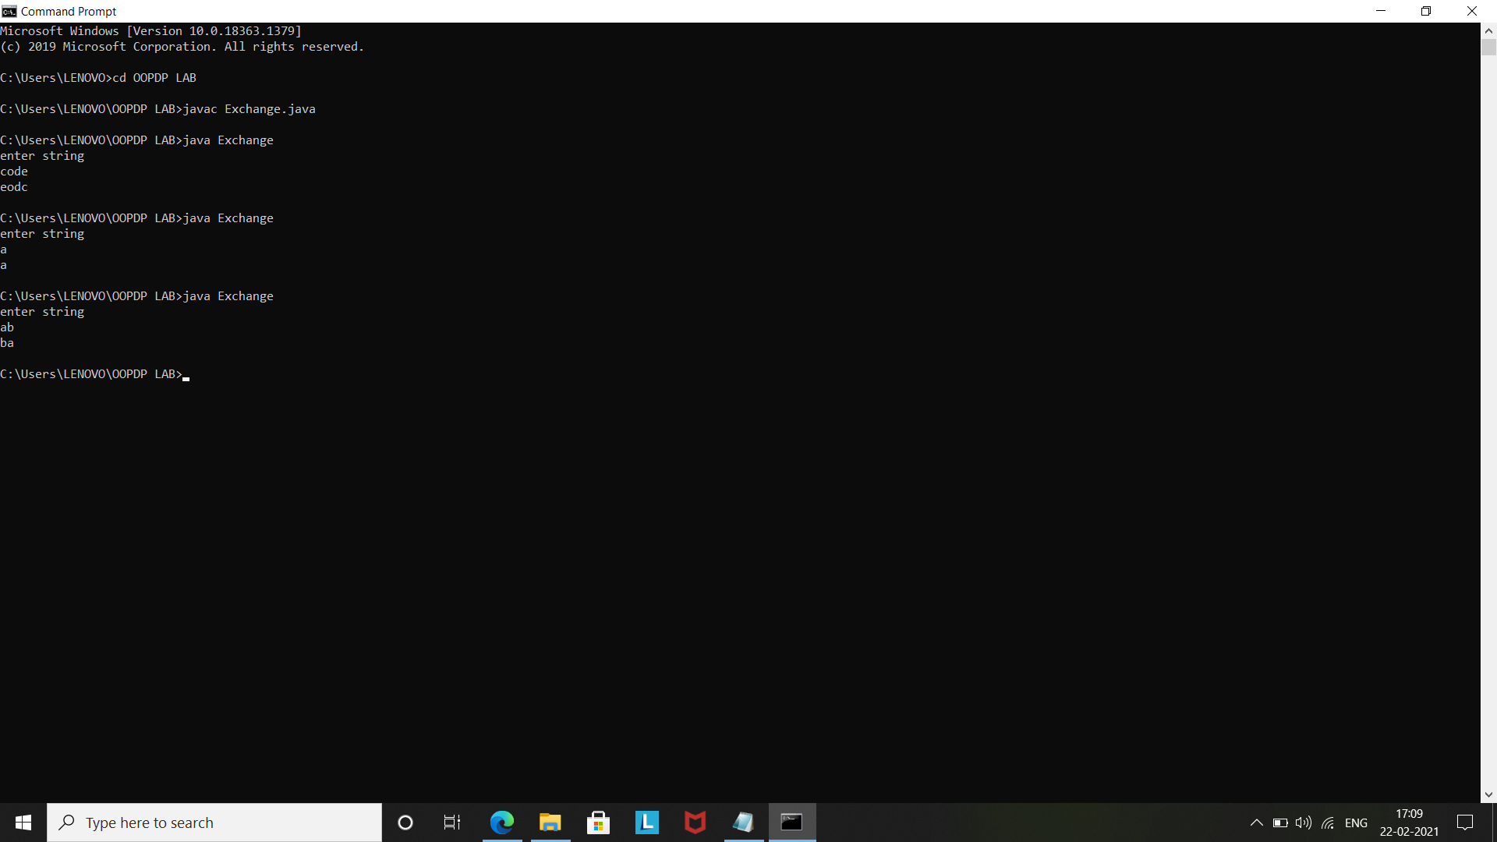

import java.util.Scanner;

public class Checkhi {

public static void main(String args[])

{

Scanner sc = new Scanner(System.in);

System.out.println("Enter the string");

String s = sc.nextLine();

System.out.println(s.startsWith("Hi"));

}

}

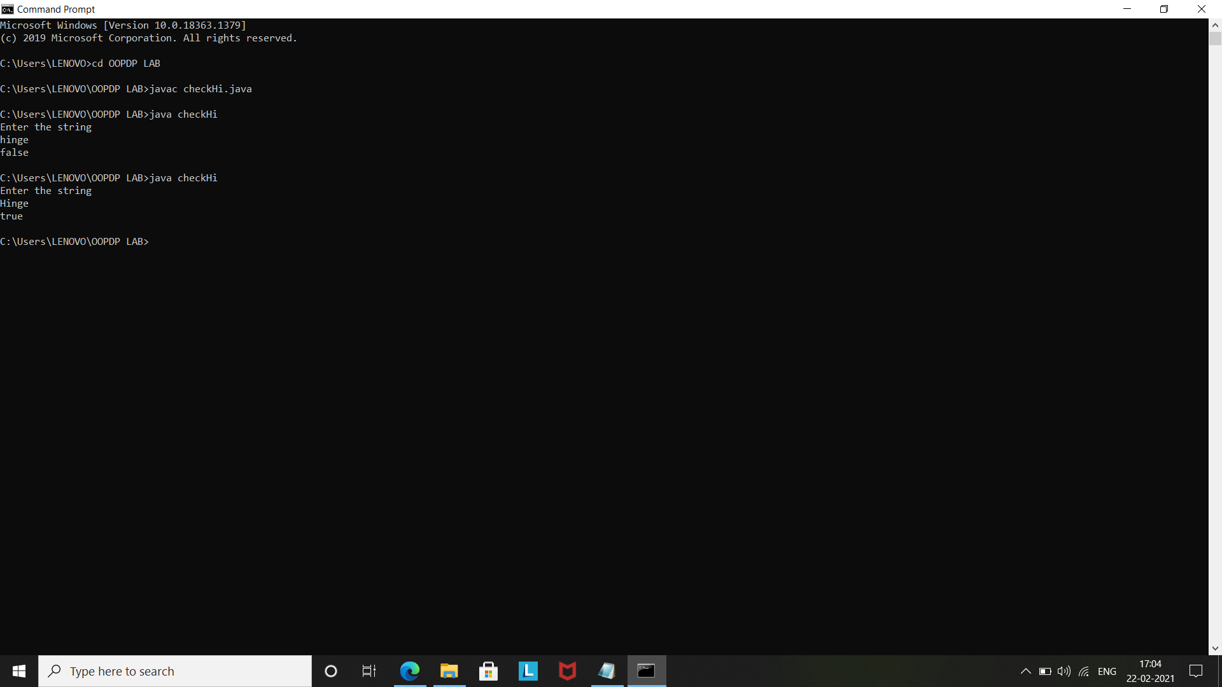

import java.util.Scanner;

import java.util.Scanner;

public class NewString{

static String lastUp(String str)

{

int len = str.length();

if (len <= 3)

return str.toUpperCase();

else

{

String temp = str.substring(len - 3, len);

return str.substring(0, len - 3) + temp.toUpperCase();

}

}

public static void main(String args[])

{

Scanner sc = new Scanner(System.in);

System.out.println("Enter string");

String str = sc.nextLine();

System.out.println(lastUp(str));

}

}

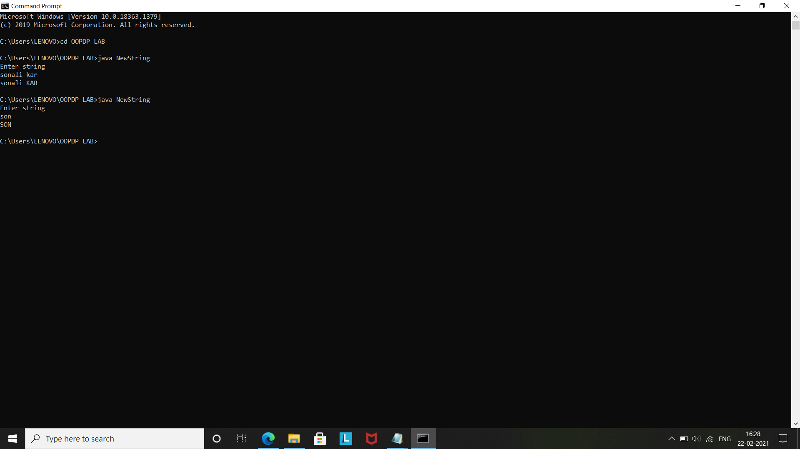

import java.util.Scanner;

public class backAroundd {

public static void main(String args[])

{

Scanner sc = new Scanner(System.in);

System.out.println("Enter string");

String s = sc.nextLine();

System.out.println(s.charAt(s.length()-1)+s+s.charAt(s.length()-1));

}

}

